Reverend Veronica Walsh Don 603-878-1684 www.masoncongregationalchurch.org

Our meditation for September: At Laila Washburn’s celebration of nearly 102 years, August 1, 2021, her family and her church friends gathered. Laila was a faithful church member all her life here in Mason. Bettie Goen and Ellen Schimke told many stories about Laila’s generous and welcoming house, to so many of the local children. Her cooking, understanding nature, and her love provided a stability when life events often rocked us. The song below was one of her favorites.
This Finnish song is entitled “Ilalaulu” (Evening Song) by Kausaulaulu

My daily work is over,
The sun is in the west,
I’ll sing my evening song now,
Then lay me down to rest.

Just like the humble birdie,
That sings in yonder tree,
No home have I to go to,
No friend to comfort me.

The Clouds now call my birdie,
Fly thither on swift wing.
And take my heartfelt sighs there,
Where heavenly angels sing.

Church is open for attendance since June—Live people!
Sundays at 10 am. All of our zoom attendees had been vaccinated. So, if other friends and members have been vaccinated, this was a good time to re-open the doors. Please wear a mask if you feel safer that way, but understand that the celebrants of the service—that is, the minister, the choir (small number), and the organist will not be masked during the service, but have all been vaccinated.
- We can easily social distance by 6 or more feet by sitting in every other pew, and sitting at opposite ends from one another.
- There are hand sanitizer and masks at the door, and you can bring your own as well.
- We will not be taking your temperature or asking you the “Covid” questions about recent exposure to Covid, symptoms, or current illness, since we know you will not come to church if you have been exposed or have any symptoms.
- No hugs, please, but an elbow bump is fun if you want to connect.
- We will make coffee but ask that you take it outside where there are chairs on the back deck, and we can add some to the driveway, or pull out one of Curt’s beautiful picnic tables.
We will continue to do a Zoom link and will happily include any Zoomers who would rather not make it to the physical building. https://us02web.zoom.us/j/82121212979 Meeting ID: 821 2121 2979
Our live Zoom is easy! You can simply click on the blue link we send out, and a window will open inviting you to say yes, “launch Zoom,” and you are in. If it is your first time on Zoom, the software will ask you to download Zoom onto your device before opening the launch window.
When you enter Zoom, the host will let you in from the “waiting room.” You are automatically muted when you enter. Simply hover your cursor arrow over the bottom (or sometimes it’s on the top) of your screen, over the little picture of the microphone. If it has a red line, you are muted. Click on it, and you are unmuted! You can stay unmuted until the service begins, at which point we are all typically silent, so we ask that you be muted until the service is over. Then we “Zoomers” have our social time, and catch up with our news, or just sharing a time of fellowship.
Join Zoom Meeting. Click on the link below or copy and paste the link into your search engine. Remember when you go to the link, you can also use your regular phone to call in, listen, and also participate. See you on Sunday! https://us02web.zoom.us/j/82121212979 Any questions, please call or text Michelle at 603 801-9140 for help!
Upcoming Events

- Old Home Day Sept 11 from 10 to 3 pm Join in the celebration of our Mason Community. There will be some music, some vendors, our Mason volunteers who run the Conservation Commission, the Mason Energy Commission, Historical Society, our Town Hall Restoration Committee, and so on. See you there!
- Ken Wilson will be 90 in September. Send him a card, or call him up and make this foray into the 90s, a new adventure. Ninety year olds are known as “nonagenarian.” I like this term, it sounds like you are not longer aging!! His address is Cahill Place, Unit 310, 486 Nashua St, Milford, NH 03055

- CROP HUNGER WALK RETURNS LIVE IN 2021 This year’s Greater Nashua Crop Hunger Walk will return on Sunday October 24, rain or shine. The walk begins at 1:30 with registration and kick-off preceding at 12:30-1:30. We will be outside for walk and celebration. If it rains, we’ll find a safe option for the celebration. To register as a walker and/or raise money go to https://events.crophungerwalk.org/2021/event/nashuanh We’re keeping a close eye on the Delta-variant Covid situation locally and will adjust and advise accordingly. Masks are always a good idea and will certainly be required for the registration and kick off programs if they are indoors. For those at high risk or uncomfortable with the group walk, we invite you to walk with a small group of family or friends throughout the month of October and raise your monies in that
- Report from the Council Meeting in July: A Council meeting was called by Dotsie, the Moderator, to decide on the memorial service request from the Washburn family. They wanted a sanctuary service, and a Fellowship Hall luncheon for Laila Washburn’s service. After much discussion about the ability of the Mason Church to provide hospitality services as have been provided for many decades, it was decided that Mason Church would clean, and prepare the hall with tablecloths, flowers, and general cleaning of the dishes, etc. but the family would prepare and serve the food. Due to the low vaccination rate of Mason and New Ipswich (below 40%) the current members were concerned about Covid 19 transmission particularly as there was a clear possibility that many of the persons attending would not be wearing masks.
Thank you to the half dozen members led by the Goens, who cleaned, set up, and tidied up for this community event. Church members did not attend the Fellowship Hall luncheon due to their own cautious approach to the pandemic.
- Mason Church Annual Meeting June 13. Any questions, contact Dotsiemill@gmail.com Dotsie can send you a digital copy of our annual meeting, if you email her. No earthshaking decisions were made, but the treasurer noted that due to decreased donations to the church, we can no longer meet our expenses and are drawing on savings.

- Nashua Soup Kitchen - News www.nsks.org 603 889-7770 You can donate online! Support our local friends. Rich, one of the managers, tells me that they are back to serving dinners, and do need volunteers. They serve all food from the kitchen counter, where you are not less than 3 ft from participants, but you are in a crowded and not well ventilated kitchen. So most volunteers are not yet back in service.
Their most recent newsletter “Bread and Board” expressed gratefulness in so many ways for the past year plus, and featured these items on a wish list:
1. Extra garden supplies, and volunteers. If you have plants or fertilizer, they ask that they be organic as their outdoor raised bed garden is organic. Tools are needed, too. Volunteers contact erika@nsks.org to sign up!
2. At the shelters, they often host children. If there is a birthday, they love to have supplies on hand to “make a party” so they can use party hats, balloons, cups and plates, and small gifts such as baby dolls, basketballs, craft sets, and gift cards for tweens and teens. You can drop these off at the soup kitchen.
3. Fund Raiser: Run/Walk for Food and Shelter is canceled for this year, but this very big fundraiser’s dollars are still very much needed. Text the code RUNWALK2021 to 44-321 or go to https://secure.givelively.org/donate/nashua-soup-kitchen-and-shelter-inc/covid-relief-for-cancelled-2021-run-walk-for-food-shelter.

- St Vincent DePaul Food Pantry Call 878-0518 or direct to Maureen 291-0022 This is our local food pantry that can always use your support. We still have our tote in the church for items. Occasionally there are items left there, and either Bettie or someone will take them to St. Vincent DePaul.
- Still on Hold--Community Supper – Team “CS” is looking forward to the day when we can cook, and share! Review the information under Church Council Meeting in July, and it will make sense on why Community Suppers are not likely to start up anytime soon. Due to low vaccination rates in our area, and the newest Delta variant of the Covid 19 virus, and the ages of the average participants in the Community Supper, it is not feasible.
- Whose land are we on? Have you ever wondered about the original inhabitants of Mason NH? Check out this website https://indigenousnh.com/land-acknowledgement/ Maybe in a future sermon or discussion we can honor this connection. How many of us have roots back to Native Americans?
The picture below is the pond between Russell Road and Sand Pit Road.
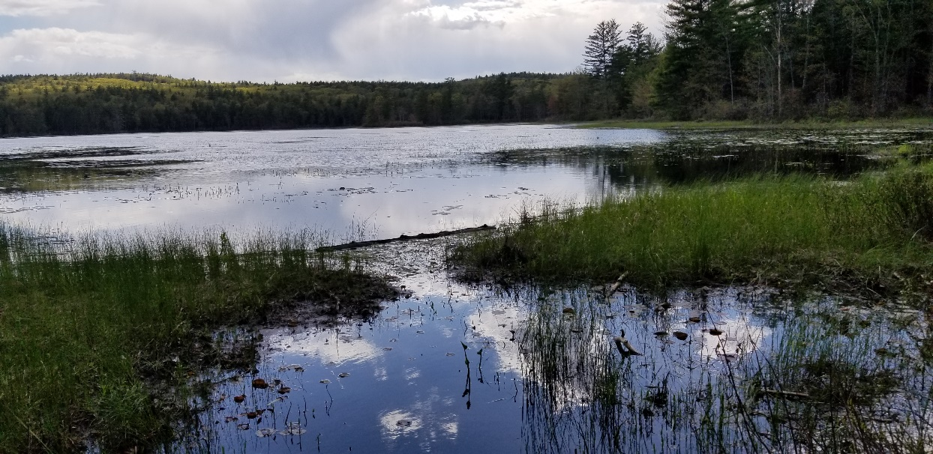

- Earth Day 2021, Every day, because every day more trash appears! The Town of Mason will pick up the Blue trash bags, if you fill them with roadside trash. Make it a family affair to pick up along your road. Being truly considerate of the environment—put all bottles and cans into a separate bag that you take to the Wilton Recyling Center. If you are not already recycling, 2021 is a great year to begin. This is your chance to beautify our corner of the world…

- Trails in Mason Mason Conservation Commission has trails for you to explore! Try the newly trimmed up Bronson Potter Trails off Greenville Road, or the Florence Roberts Trail off Valley Road. Go to the Town website, and find more info under the Conservation Commission tab. This is a way to refresh your soul in nature, and to energize your body.
Remember our church family in your prayers, a call, or a card. Loneliness can be relieved by caring and connection, at least temporarily, and price of this “gift” is mostly free!

- Harry Spears Remember Harry as he continues to heal from the heart surgery he had last fall. You can send cards to his home, 966 Starch Mill Rd, Mason, NH 03048. Or give him a call at 400-9209 Harry has been a friend of Mason Church for many years and participated in worship this summer under the Maple Tree. A special time for all!

- Karin Eisenhaure had knee surgery in April, and while recuperating she fell and broke her ankle on the same leg. Talk about adding insult to injury! She has had surgery to patch up the ankle, and faces a tedious recovery and strength gathering for many weeks, and some of that time will be spent in a rehab center. She is now at Greenbriar Rehab and Healthcare, 55 Harris Road, Nashua, NH 03062 1-978-402-2208. Call or visit, and be a cheerleader during her time of pain and separation from her home, adorable dog, “Baby”, and beloved garden.

- Wally Brown Wally’s Gretchen died In June of complications of Parkinson's Disease. An outdoor service was held in June at the Mason Congregational Church. Wally and Gretchen were married for 18 years. Though the last few years have been hard for both of them, they had many fine memories to keep Wally going. To acknowledge his loss, send cards to: 421 Meetinghouse Hill Rd, Mason, NH 03048 phone: 878-1481

- Susan and Jim Suokko go to Florida in winter. Their Florida address is: 8814 28th Ave. Palmetto, FL 34221. They are a permanent part of our church family, so keep in touch with them! During the summer months, they are here in the area, and you can find them at: 50 Brooks Pond Rd, Apt 104, Leominster, MA 01453. Call Susan or text at 978-386-2422 email: usercat2@comcast.net

- Prayer Shawl Ministry Speaking of Susan Suokko… she has been the backbone of the Prayer Shawl Ministry, and has passed the baton to Mason Church Diaconate. Thank you to Karin Eisenhaure, Sally Wilson, and Cindy Tibbetts for their knitted prayer shawls. We continue to have calls from members, friends of friends, or relatives of friends who want a special shawl. We can mail these out, please request through Pastor Veronica or a Deacon. We sew on a 3-inch crocheted cross, if requested, and adapt the Prayer Shawl poem with the person’s name, and the names of family members if indicated. Knitters needed! We can provide yarn and patterns for any knitters. Contact Michelle 878-1680 or miscott39@gmail.com.

- Kathy Wile’s sudden passing in January left us all so sad. You can contact her husband, Gerry Wile, at 717 Hurricane Hill Rd, Mason, NH 03048 878-2904 wgl717hur@aol.com. A Service was held on July 17, in the cemetery, conducted by the family and Reverend Veronica Walsh Don. Gerry Wile and friends played at this beautiful service. Their music echoed the love we all felt for Kathy, and our community love.

- Since the pain from loss of a loved one does not end with one card, or one kind act. If you can, reach out to those suffering from loss, not only of life, but loss of mobility, or good health. It is kind to remember the family on the anniversary of their passing, or really, any time.

Peg Schuster/Morrison was a Mason Church member until her death in 2010, and offered rides to shut-ins and anyone who needed help. She would have been one of the first to volunteer for Community Volunteer Transportation Services, CVTC! See below. Follow in the footsteps of such a special person by helping get those who can no longer drive to where they need to be!

Now Is the Time!
Volunteers needed now! You can volunteer once a week, a few times a month, or more often! If you are away or on vacation, another driver can take over. You will meet the most interesting people, and even some of your neighbors!
CVTC riders are booking more rides, and they need you! As the demand for rides is returning to pre-pandemic levels (250-300/month), CVTC has a pressing need for more Volunteer Drivers. When our supply of Volunteer Drivers increases, we can better meet the needs of people requesting rides to essential appointments—doctor appointments, groceries, pharmacy, bank, post office. You can be reimbursed for mileage!
Please call 603-821-0569 to speak with a Transportation Coordinator. For details, visit cvtc-nh.org or go to Community Volunteer Transportation Company on Facebook to check us out.
CVTC, 375 Jaffrey Rd., Suite 3, Peterborough, NH 03458; toll free 1-877-428-2882 ext. 5

